**Advanced Prototyping Project Outline**

* **00-ProjectPoster.pdf**
  + Hero Image
  + Project Title
  + Full Name
  + Course Information
  + Semester/Year
  + Summary of Sections 01-09
* **01-ConceptDevelopment.pdf**
  + Problem Statement - In one sentence, define the problem that your design proposes to solve. Be specific about the who it is for and the problems you’re trying to address.
  + Proposed Idea - Describe your proposed solution to your problem statement in broad terms and what approach you will take to solve the problem.
  + Influences - List three influences that you will draw from to create your solution.
    - Influence Name
    - Reference Image
    - Explanation of Influence
    - Source URL
* **02-FormProposal.pdf**
  + Mood Board - Identify at least 4 important characteristics of your device. Create a full page mood board with external references that explore those characteristics.
  + Aesthetic Concepts - Create 3 visual concepts of your device that consider both the functional constraints and ergonomic considerations of your user.
    - Concept Name
    - Concept Sketch with Labels
    - Description and Justification
  + Concept Summary - Summarize the strengths and weaknesses of each design. Write a short description of the features your proposed device will have based on this analysis.
* **03-FunctionProposal.pdf**
  + Hardware - Create a comprehensive list of the hardware your device will require to function.
    - Inputs - List the hardware inputs will the user interact with. You must include at least on non-push button/switch sensor.
      * Sensor Name
      * Function Description in Device
      * Documentation Source URL (Libraries, Schematics, Guides, etc.)
    - Processing - Describe the processing platform will your device use. This should be the least expensive/complicated platform possible. You are limited to the following processors: ATTiny85, Arduino Pro Mini/Micro, Teensy 3.2, Adafruit Huzzah, or Raspberry Pi Zero W (requires approval)
      * Processor Name
      * Justification for Processor Choice (including advantages and disadvantages)
      * Documentation Source URL (Libraries, Schematics, Guides, etc.)
    - Outputs - What outputs will your device use communicate with the user? You must include a graphical screen and are limited to the following options ([1](https://www.amazon.com/gp/product/B008HWTVQ2/ref=oh_aui_detailpage_o04_s00?ie=UTF8&psc=1), [2](https://www.amazon.com/gp/product/B00SK6932C/ref=oh_aui_detailpage_o04_s01?ie=UTF8&psc=1), [3](https://www.amazon.com/gp/product/B01EUVJYME/ref=oh_aui_detailpage_o07_s00?ie=UTF8&psc=1), [4](https://www.amazon.com/gp/product/B01G6SAWNY/ref=oh_aui_detailpage_o07_s01?ie=UTF8&psc=1), [5](https://www.amazon.com/gp/product/B0045IIZKU/ref=oh_aui_detailpage_o08_s00?ie=UTF8&psc=1))
      * Output Name
      * Function Description in Device
      * Documentation Source URL (Libraries, Schematics, Guides, etc.)
    - Power - Explain the hardware necessary to power your device. Devices must be powered via LiPo batteries, and should be rechargeable and monitor for low power conditions.
      * Power-Related Hardware Name
      * Function Description in Device
      * Documentation Source URL (Libraries, Schematics, Guides, etc.)
  + Software
    - Create a comprehensive list of software that you will use to develop your hardware. Include any libraries, drivers, etc. not listed in hardware.
      * Software Name
      * Functional Description
      * Documentation Source URL (Reference, Guides, etc.)
* **04-FunctionDevelopment.pdf**
  + Wireframe Storyboard - Model your software by creating wireframe diagrams using **Balsamiq Mockups**. Show the various states of your device and a description of how the user interacts with them. It should include:
    - Splash Screen
    - Home Screen
    - Functional Modes (at least 2)
    - Help Screen
    - About Screen
  + Component Sketch - Create a component sketch showing the various high-level systems that will be included in your physical prototype using **draw.io**. Make sure to label all connections and use the following parameters:
    - Inputs - Diamond shape
    - Processors - Square shape
    - Outputs - Circles shape
    - Power - Hexagon shape
  + Bill of Materials - Create a comprehensive bill of materials that includes part names, manufacturing sources, quantities and cost.
    - Item Name
    - Item Cost
    - Quantity Required
    - Purchase URL
    - Reference URL (schematic, guides, etc.)
  + Breadboard Model - Create a breadboard model in **Fritzing** simulating your circuit. Components should be well spaced and wire jumpers should be discernible.
  + Electronic Schematic - Create an electronic schematic in **Fritzing** showing your circuit with appropriate connections made in a well organized manner.
* **05-FunctionProof.pdf**
  + Functional Breadboard - Build your circuit on a breadboard using temporary connections.
    - Breadboard Image with Labels
    - Multiple State Images with Descriptions
    - Commentary on proposed concept compared to proof of concept
  + HelloWorld Software - Include a copy of your software in your repository.
    - Include any libraries necessary to compile the software
    - Well-formatted code is required with helper functions labeled and described with comments
  + PCB Design - Design a 2 layer printed circuit board in **Fritzing** using your previous work as a guide with the following considerations:
    - Minimize the overall footprint to reduce costs
    - Consider placement and mounting in physical device
    - Design Rules Check your circuit prior to submission
  + PCB Paper Test - Print your PCB images on paper and glue them to foam core. Test fit your components on the foam core to ensure proper spacing
    - Include images with labeled dimensions
* **06-FormProof.pdf**
  + Refined Dimensional Sketches - Using graph paper, create an accurately scaled drawing from multiple perspectives of your design
  + Foam Model - Created a model of your design using green foam
    - Model should be 1:1 scale
    - Surface should be sanded and sealed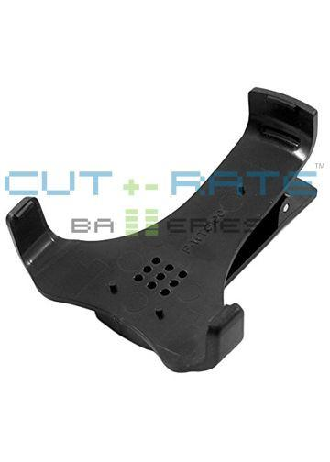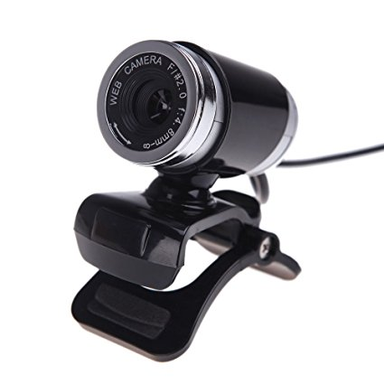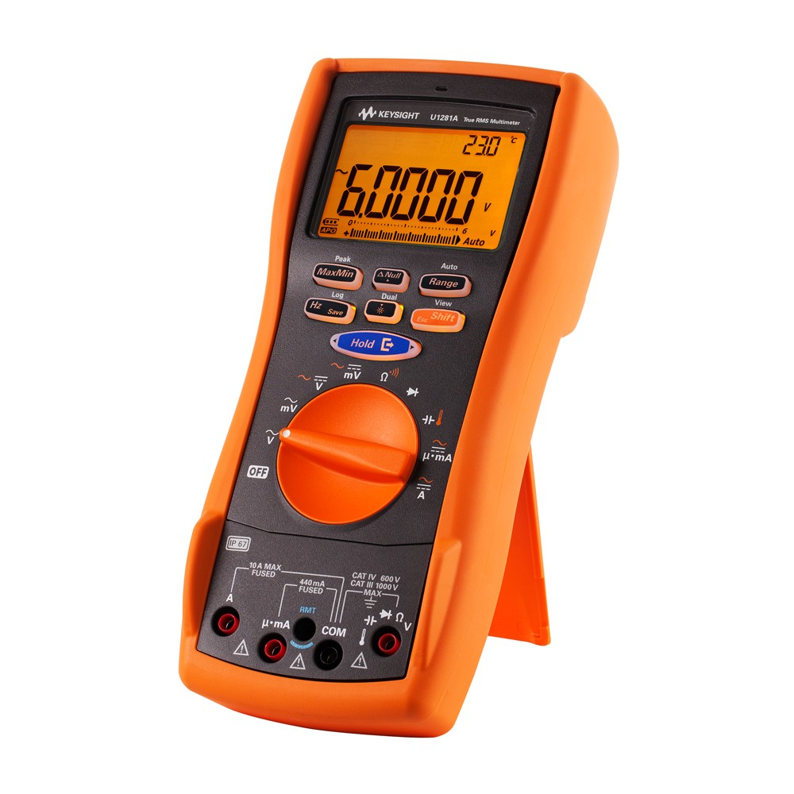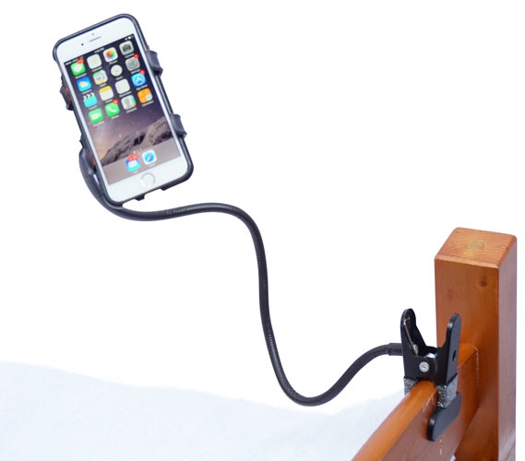
  + Virtual 3D Model - Create a 3D model of your device in **Fusion 360**
    - Model should be to dimensions detailed in sketches and foam model (with reasonable deviations as necessary)
    - Renderings should include surface treatments and show device from the top, isometric, side, bottom, and exploded views.
* **07-FunctionProduction.pdf**
  + Finalized Software - Include a link to your finalized software including all refinements, comments, and bundled libraries.
  + Printed PCB - Solder components to your printed circuit board (SMD and THT soldering) and test your circuit to ensure functionality
* **08-FormProduction.pdf**
  + 3D Printed Model - Fabricate a 3D printed model based on your Fusion 360 model
    - Include any additional hardware such as standoffs, screws, etc. necessary to complete the design
* **09-Finalization.pdf**
  + Complete Project - Combine the functional and form components together into a completed prototype.
  + User Testing - Generate a practical test of your device that includes a test of its hardware, software, and aesthetic features
    - Test with 3 individuals and record your results
  + Power Requirements and Performance - Subject your device to power testing.
    - Test under the following conditions: idle performance, moderate usage, and frequent usage for 30 minutes each
* **10-Reflection.pdf**
  + Comment on modifications and adjustments you had to make to bring the functional and form components together. What worked well? What would you do differently?